Caleb & Simone’s Wedding July 2025

Your Will be done

[Intro]
C Am F C (x2)

[Verse 1]
C F
Your will be done, my God and Father
C Am G
As in heaven, so on earth
C F
My heart is drawn to self-exalting
C G C
Help me seek Your Kingdom first

[Chorus 1]
C F
As Jesus walked, so I shall walk
C Am G
Held by Your same un - changing love
C F C
Be still my soul, O lift your voice and pray:
F C G C ‘Father, not my will, but Yours be done.’

C Am F C

[Verse 2]
C F
How in that Garden He persisted
C Am G
I may never fully know
C F
The fearful weight of true obedience
C G C
It was held by Him alone

[Chorus 2]
C F
What wondrous faith, to bear that cross
C Am G
To bear my sin, what wondrous love
Am C/E F C/E
My hope was sure, when there my Saviour prayed:
F C G C
‘Father, not my will, but Yours be done.’

C Am F C

[Verse 3]
C F
When I am lost, when I am broken
C Am G
In the night of fear and doubt
C F
Still I will trust in my good Father
C/E G C
Yes, to one great King I bow!

[Chorus 3]
C F
As Jesus rose, so I shall rise
C Am G
In ransomed glory at the throne
C C/E F C
My heart restored, with all Your saints I sing:
F C G C
‘Father, not my will, but Yours be done!’

C Am F C

[Verse 4]
C F
As we go forth, our God and Father
C Am G
Lead us daily in the fight
C/E F
That all the world might see Your glory
C/E G C
And Your Name be lifted high!

[Chorus 4]
C F
[And in this Name we overcome
C Am G
For You shall see us safely home
Am C/E F C
Now as Your church, we lift our voice and pray:
F C G C
‘Father, not my will, but Yours be done!’] x2

[Tag]
C/E F C G Am
‘Father, not my will, but Yours be done’
C/E F C G C
‘Father, not my will, but Yours be done’

[Outro]
C Am

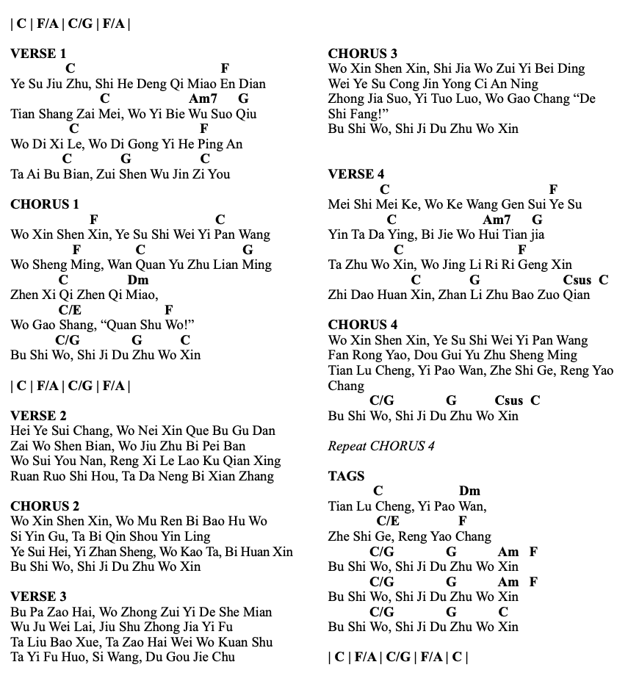
Yet Not I But Through Christ In Me
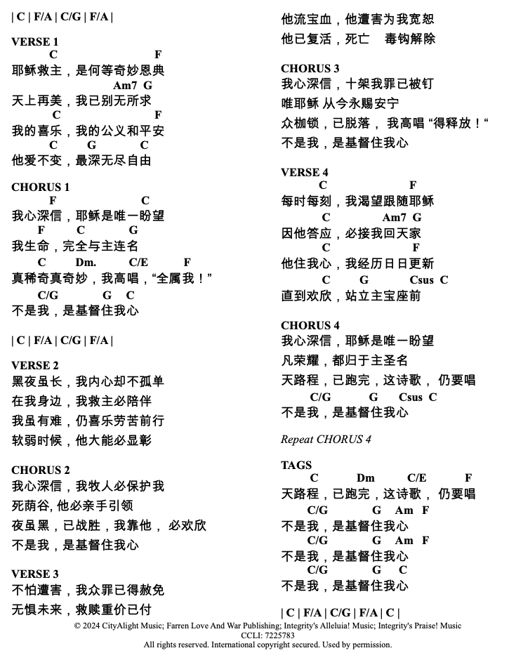
Yet Not I But Through Christ In Me

[Verse 1]
C F
What gift of grace is Jesus my redeemer,
C Am Gsus G
There is no more for heaven now to give
C F
He is my joy, my righteousness, and freedom
C G Csus C
My steadfast love, my deep and boundless peace

[Chorus 1]
F C
To this I hold, my hope is only Jesus
F C Gsus G
For my life is wholly bound to his
C Dm C/E F
Oh how strange and divine, I can sing: all is mine!
C/G G C
Yet not I, but through Christ in me

C F/A C/E F/A

[Verse 2]
C F
The night is dark, but I am not forsaken
C Am Gsus G
For by my side, the Saviour He will stay
C F
I labour on in weakness and rejoicing
C Gsus G Csus C
For in my need, His power is displayed

[Chorus 2] Piano Rhythm
C/E F C
To this I hold, my Shepherd will defend me
F C Gsus G
Through the deepest valley He will lead
C Dm C/E F
Oh the night has been won, and I shall overcome!
C/G G C
Yet not I, but through Christ in me

[Interlude]
C F/A C/E F/A

[Verse 3] Straight Beat
C F
No fate I dread, I know I am forgiven
C Am Gsus G
The future sure, the price it has been paid
C F
For Jesus bled and suffered for my pardon
C Gsus G Csus C
And He was raised to overthrow the grave

[Chorus 3]
C/E F C
To this I hold, my sin has been defeated
C/E F C Gsus G
Jesus now and ever is my plea
C Dm C F
Oh the chains are released, I can sing: I am free!
C/G G C
Yet not I, but through Christ in me

C F/A C/E F/A

[Verse 4]
C F
With every breath, I long to follow Jesus
C Am Gsus G
For He has said that He will bring me home
C F
And day by day I know He will renew me
C Gsus G Csus C
Until I stand with joy before the throne

[Chorus 4]
C/E F C
To this I hold, my hope is only Jesus
C/E F C Gsus G
All the glory evermore to Him
C Dm C/E F
When the race is complete, still my lips shall repeat:
C/G G Csus C
Yet not I, but through Christ in me!

C/E F C
To this I hold, my hope is only Jesus
C/E F C Gsus G
All the glory evermore to Him
C Dm C/E F
When the race is complete, still my lips shall repeat:
C/G G Csus C
Yet not I, but through Christ in me!

[Tag]
C Dm C/E F
When the race is complete, still my lips shall repeat:
C/G G Am F
Yet not I, but through Christ in me!
C/G G Am F
Yet not I, but through Christ in me!
C/G G C
Yet not I, but through Christ in me!

[Outro]
C F/A C/E F/A\
Build my life (E)

INTRO:
E A E A

VERSE:
E A/E
Worthy of every song we could ever sing
E A/E
Worthy of all the praise we could ever bring
E A/E
Worthy of every breath we could ever breathe
E/G# A/E
We live for You
E A/E
Jesus, the name above every other name
E A/E
Jesus, the only one who could ever save
E A/E
Worthy of every breath we could ever breathe
E/G# A/E
We live for You. Oh, we live for You

CHORUS:
A9 F#m7
Holy, there is no one like You
E
There is none beside You
C#m7
Open up my eyes in wonder
A9
Show me who You are
F#m7
And fill me with Your heart
E C#m7
And lead me in Your love to those around
A9
me

VERSE

CHORUS x2

Interlude:
A9 Bsus C#m7 E/G# x2

BRIDGE:
A9 Bsus C#m7
I will build my life upon Your love
E/G#
It is a firm foundation
A9 Bsus C#m7
I will put my trust in You alone
E/G#
And I will not be shaken x2

CHORUS x2

BRIDGE

OUTTRO

